Book Reading List Using Linked List
1. Title
Book Reading List Using Linked List
2. Problem Statement
Develop a Book Reading List Management System using a Singly Linked List in C++. The system should allow the user to add, display, search, delete, and count books in the reading list. Each book should be stored in a separate node containing the book name and a pointer to the next node.
3. Objective
- To understand the concept of a Singly Linked List.
- To create and manage nodes dynamically.
- To add books to the reading list.
- To display all books in the list.
- To search for a particular book.
- To delete a book from the list.
- To count the total number of books.
- To understand dynamic memory allocation in C++.
4. Algorithm
Step 1:
Start the program.
Step 2:
Create a Node structure containing:
- bookName
- next pointer
Step 3:
Initialize head as NULL.
Step 4:
Display the menu:
- Add Book
- Display Books
- Search Book
- Delete Book
- Count Books
- Exit
Step 5:
If the user selects Add Book:
- Create a new node.
- Enter the book name.
- If the list is empty, make the new node the head.
- Otherwise, traverse to the last node and connect the new node.
Step 6:
If the user selects Display Books:
- Start from head.
- Display each book.
- Move to the next node until NULL is reached.
Step 7:
If the user selects Search Book:
- Enter the book name.
- Compare it with each node.
- Display "Book found" if a match is found.
- Otherwise display "Book not found".
Step 8:
If the user selects Delete Book:
- Enter the book name.
- Search for the book.
- Change the links to remove the node.
- Delete the node from memory.
Step 9:
If the user selects Count Books:
- Traverse the linked list.
- Increase the counter for every node.
- Display the total number of books.
Step 10:
If the user selects Exit, terminate the program.
Step 11:
Stop.
Flowchart

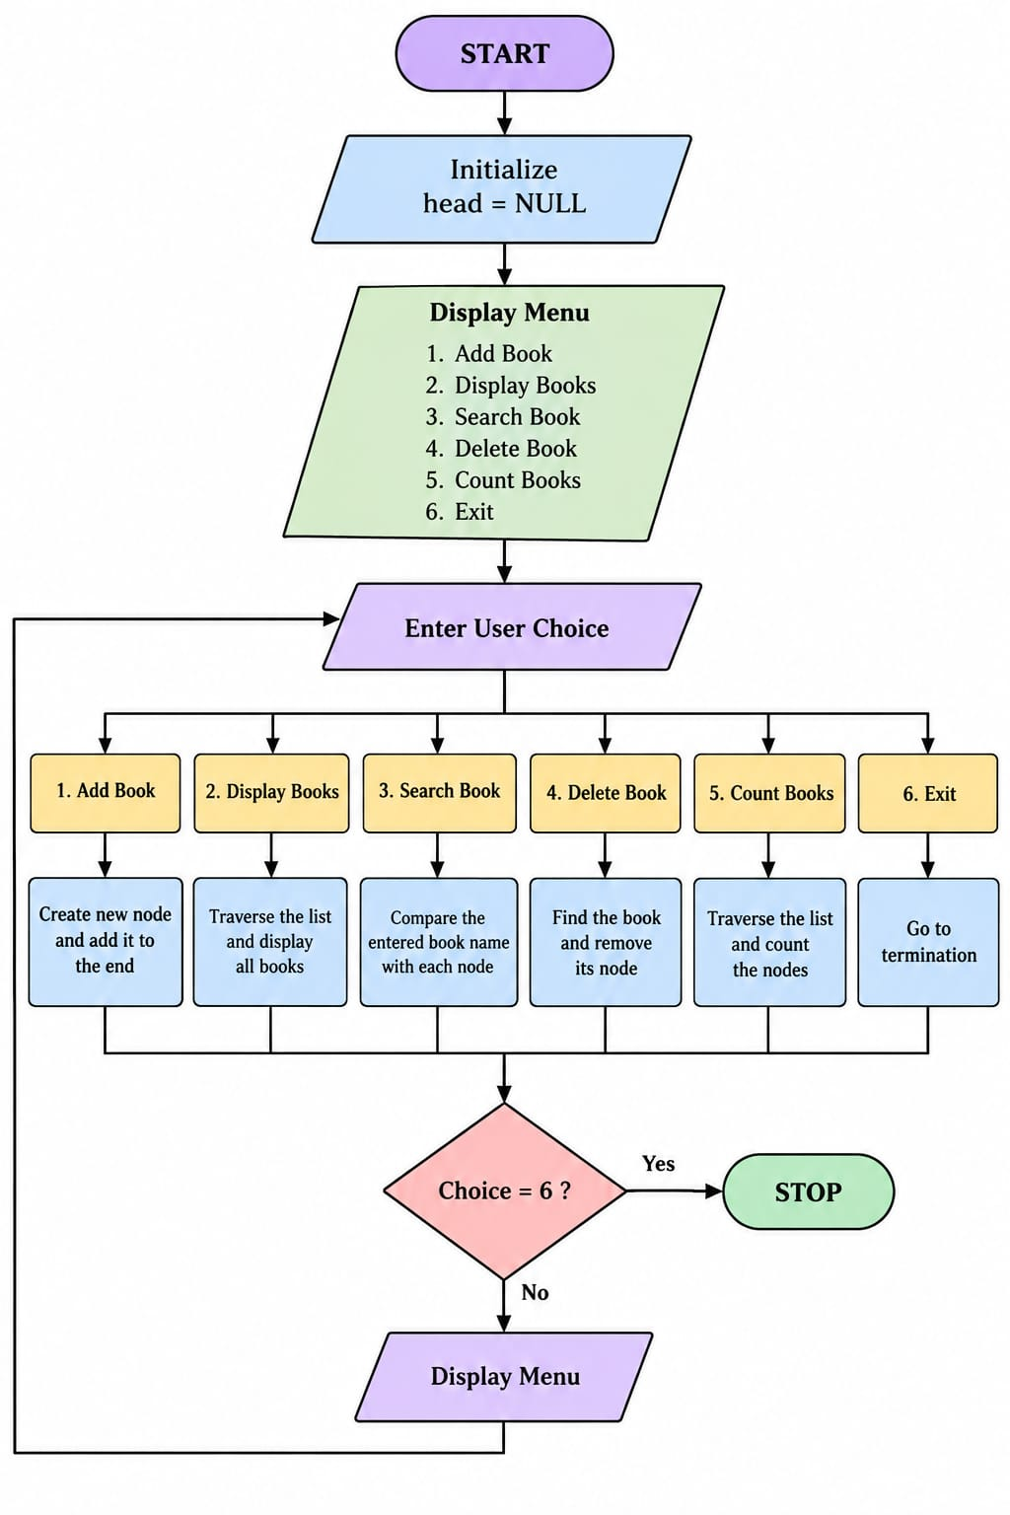

Conclusion
The Book Reading List Using Linked List program successfully demonstrates the implementation of a Singly Linked List in C++. It performs important operations such as insertion, traversal, searching, deletion, and counting. This project helps in understanding linked lists and dynamic memory allocation through a simple real-life application.

